# CS 340 README Template

## About the Project/Project Title

The client, Grazioso Salvare, is an international rescue-animal training company that are seeking to implement a software application that is compatible with their current data to identify and categorize their search-and-rescue animals. The database must be able to index the current database as well as being able to apply create, read, update, and delete (CRUD) functionalities.

## Motivation

The project is to demonstrate how to implement CRUD operations to create, read, update, and delete in Python. Using CRUD operations helps to reduce the complexity of data storage and enables focusing on the functionality and usability of the application.

## Getting Started

* Users must log onto the MongoDB terminal and ensure the correct CSV file was imported properly.

Note: The account used only has access to read and write as well as limited access to the following database: Austin Animal Center (AAC).

* + Users must enter credentials to ensure accounts are authenticated.

* + The test all access is granted properly, see image below:

* Using the files “animalShelter.py” & “testScript.ipynb” are needed to access the code and testing station.

**Installation**

* MongoDB – Installation guide can be found [here](https://www.mongodb.com/docs/manual/installation/).
  + MongoDB is a cloud-based system that will be used to distribute the AAC database across multiple servers. MongoDB will also provide scalability when expanding storage capacity and other data-driven applications.
* PyMongo – Installation guide can be found [here](https://pypi.org/project/pymongo/).
  + PyMongo, with its set of tools, is used to build the CRUD commands and communicate with the MongoDB server.
  + Jupyter Notebook is an open-source web application for developers to create, share, and edit the code. Jupyter Notebook also has a testing station for the code workflow making it easier for developers to compile all portions of the data project in one place.
* Spyder – Installation guide can be found [here](https://docs.spyder-ide.org/3/installation.html).
  + Spyder is an IDE that uses the Python language that allows developers to create a project that is user-friendly by including syntax errors, installation packages, and console testing.

## Usage

### Code Examples

* Using the code “from pymongo import MongoClient” will ensure the PyMongo libraries will be imported into the Python Code.
* Using the code “from bson.objectid import ObjectId” will enable the construct to access MongoDB
* The create function will enable developers to create variables in the database. The syntax will return “True” if the execution passes and return “False” if the execution fails.
* The read function will allow users to view the database. Users can search for one or multiple variables within the search function, as long as all data exists.
* **Code to Initialize the Client** 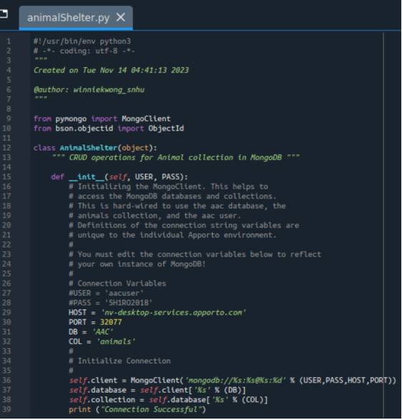
* **Code to Create & Read Within the Index** **A screen shot of a computer screen

  Description automatically generated**

### Tests

* **Ensuring log in was successful.**
  + When the log in is successful, there will be a notification of its success.

* **Testing the “create” operation.**

* **Testing the “read’ operation.**A screenshot of a computer program

  Description automatically generated

## Roadmap/Features (Optional)

Currently the application focuses on account information, and the create and read functionality of the CRUD module. The project has also focused on accessibility, testability, scalability, and maintainability to ensure industry-standard best practices are in used for readability and reusability.

Future updates of the module will include the update and delete functionality to complete all aspects of CRUD. The project vision will apply the database concepts and principles to develop a client/server application with the created database that will interface with the client-side code.

## Contact

Your name: Winnie Kwong